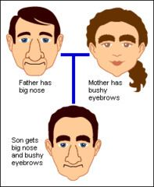
INHERITED TRAITS –
a characteristic that is passed from parent to offspring

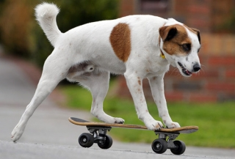
LEARNED BEHAVIOR –
a behavior an animal learns from its parents

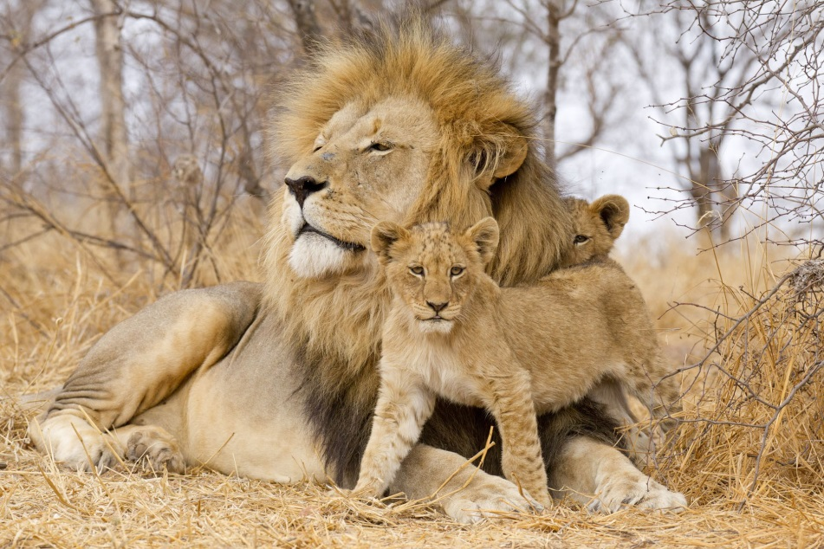
OFFSPRING –
the young of a person, animal or plant

PHYSICAL TRAITS –
the physical characteristics or features of an organism
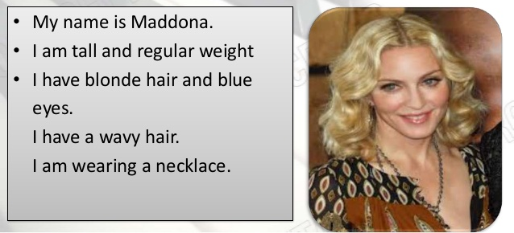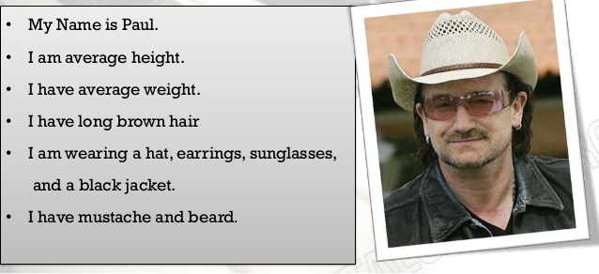

REPRODUCTION –
making more organisms of the same kind
