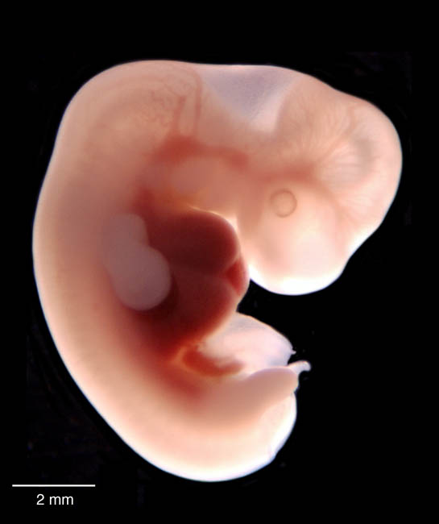
EMBRYO –
The first stage of an animal’s life cycle, right after fertilization of an egg.

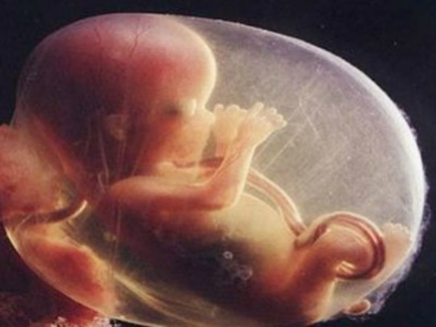
FETUS –
The second stage of an animal’s life cycle.
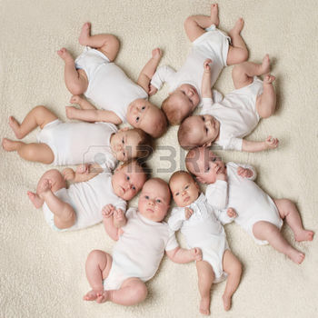
BABY –
The stage of human life right after birth.

CHILD –
The stage of human life between a baby and a young adult.

YOUNG ADULT –
The stage of the human life cycle that is right before adulthood.

